CASE-3 MORTGAGE PAYBACK ANALYTICS
Nikitha Deekonda
4254312
CSDA 6010 Analytics Practicum
Professor: Willie Rivers

Introduction:
This project explores how people repay their mortgages over time by using a large dataset of 50,000 U.S. borrowers. The data tracks each borrower for up to 60 months and records how their loan balance, interest rate, credit score, and home value change over time. It also includes broader economic conditions like unemployment, GDP growth, and the house price index. Together, these details help us understand how both personal financial factors and the economy influence mortgage repayment.
In this dataset, most borrowers continue making payments as expected, but a smaller group either pays off the loan early or goes into default. About 93% of borrowers remain active, around 4% fully repay their loan early, and about 2% default. On average, borrowers start with a FICO score around 674, an LTV of about 79%, and an interest rate close to 5.7%. Their loan balance naturally decreases over time as they make payments.
The purpose of this project is to build models that help explain and predict borrower behaviour. We use classification models to identify who might default, regression models to understand how early someone might pay off their mortgage, and clustering models to group borrowers with similar risk or financial characteristics. These approaches help highlight what factors truly matter when it comes to mortgage outcomes.
From a business point of view, these insights are extremely useful. If lenders can predict who is likely to default or prepay early, they can set interest rates more fairly, manage financial risk, and plan their cash flows better. Clustering helps them understand different types of borrowers so they can offer more personalized and balanced loan pricing. Overall, this project shows how data analytics can turn raw mortgage data into meaningful insights that support smarter decisions and healthier financial portfolios.

Business and analytics goals

Business Problems:
1. High Default Risk and Financial Losses
A sizable portion of borrowers fail to make their mortgage payments on time, resulting in loan defaults. Default events create direct financial losses for lenders through unpaid balances, foreclosure expenses, and administrative recovery efforts. In this dataset, approximately 15,154 out of 50,000 borrowers (≈30%) have defaulted at least once. Defaulted borrowers also carry higher average balances ($252,479) compared to non-defaulted borrowers ($245,802), highlighting that larger loans are at greater risk of loss. Early identification of high-risk borrowers is therefore critical for minimizing losses, improving loan monitoring, and maintaining portfolio stability.
2. Uncertain Prepayment Behaviour and Cash-Flow Instability
Many borrowers repay their mortgages significantly earlier than scheduled, often due to refinancing, home sales, or changes in financial conditions. The dataset shows that about 53% of borrowers (26,589) prepaid their loans, doing so an average of 105 periods before maturity. Early prepayments reduce the total interest income lenders expect to earn and create challenges in predicting cash inflows. This uncertainty makes liquidity planning, reinvestment decisions, and revenue forecasting more difficult. Accurately predicting prepayment timing is therefore essential for maintaining stable cash flows and improving financial planning.
3. Inefficient Risk Assessment and Loan Pricing
Borrowers in the dataset exhibit a wide range of credit and risk characteristics FICO scores ranging from 400 to 840, LTV ratios from 50% to 218%, and interest rates from 0% to 19.75%. Despite this large variability, many borrowers receive similar loan pricing. Some high-risk borrowers are charged lower interest rates than safer borrowers, leading to inconsistent and suboptimal pricing decisions. This mismatch results in mispriced loans, reduced profitability, and increased portfolio risk. Identifying borrower segments and aligning interest rates with actual risk levels is necessary to improve pricing strategy, enhance competitiveness, and maintain long-term financial health.
Business Goals:
1. Reduce Default-Related Losses through Predictive Risk Modelling
The first goal is to use predictive analytics to identify borrowers who are likely to default before the event occurs. By leveraging key credit, loan, and economic indicators such as FICO score, LTV ratio, interest rate, GDP growth, and unemployment rate lenders can classify borrowers based on their risk levels. Early detection allows lenders to intervene through restructuring, counselling, or targeted communication. The objective is to reduce default incidence by 10–15%, thereby lowering financial losses from unpaid balances, foreclosures, and recovery costs.
2. Improve Cash-Flow Forecasting through Prepayment Timing Prediction
Early mortgage payoff significantly affects the timing of cash flows and long-term interest income. To address this, the project aims to build a regression model that predicts how early a borrower is likely to prepay relative to the loan’s scheduled maturity. Accurate prepayment timing forecasts help lenders anticipate principal returns, plan reinvestment strategies, and maintain liquidity. The goal is to increase the accuracy of cash-flow forecasts, reduce volatility, and support more reliable financial planning.
3. Optimize Loan Pricing and Portfolio Profitability through Data-Driven Segmentation
Borrowers in the dataset display wide differences in creditworthiness and financial behaviour, yet many receive similar loan pricing. To address this inefficiency, the project aims to use clustering techniques to group borrowers into meaningful segments based on risk, credit profile, and loan characteristics. By aligning interest rates more closely with actual borrower risk, lenders can reduce pricing inconsistencies by 20–25%, improve profitability, and maintain fair, competitive, and transparent pricing practices. Risk-adjusted pricing also helps strengthen portfolio stability and enhances customer trust.

Analytical Goals:
The main analytical goal of this project is to use the data to understand how borrowers behave over the life of a mortgage and to build models that can predict important outcomes. These goals directly support the business needs of lowering default losses, improving cash-flow planning, and making loan pricing fairer and more consistent.
1. Predict Which Borrowers Are Likely to Default
To help lenders spot risky borrowers early, this project will build classification models that estimate the chance a borrower will default. These models will use information like the borrower’s FICO score, loan-to-value (LTV) ratio, current balance, interest rate, and broader economic conditions such as unemployment and GDP growth. The goal is to correctly identify high-risk borrowers ahead of time so lenders can take preventive steps and reduce potential financial losses.
2. Predict How Early Borrowers Might Pay Off Their Loans
Since many borrowers close their loans early often much earlier than expected this project will also build regression models that estimate how many periods early a borrower is likely to prepay. These models will help explain which factors lead to early payoff, including changes in interest rates, borrower credit strength, and housing market conditions. The goal is to give lenders a clearer idea of when cash flows will arrive so they can plan investments and manage liquidity more effectively.
3. Group Borrowers into Segments for Fairer and More Accurate Pricing
Not all borrowers have the same level of financial risk, but many receive similar interest rates. To address this, clustering techniques will be used to group borrowers into segments based on their credit profile, loan characteristics, and repayment behaviour. By comparing interest rates across these groups, we can identify whether loans are being priced fairly and consistently. This helps lenders set better, more informed pricing strategies that balance profitability with fairness.
By combining prediction and segmentation methods, this project aims to turn raw mortgage data into clear, useful insights. These insights will help lenders make smarter decisions whether it’s identifying risky borrowers early, planning for shifts in cash flow, or setting interest rates that truly match borrower risk.

Analytical Approach:
The analysis begins by carefully reviewing and preparing the data to make sure every borrower record is accurate and usable. This includes checking for missing values, correcting zeros where necessary, and filling in gaps with reasonable estimates. Numeric values such as FICO score, loan-to-value (LTV), interest rate, and loan balance are adjusted to be on a similar scale so that no single variable overwhelms the others. Categorical fields like property type and whether the borrower is an investor are converted into numerical form so they can be used in modelling. Additional features, such as how a borrower’s balance or LTV changes over time and how early they close their loan, are created to better reflect repayment patterns.
Once the data is cleaned, exploratory analysis is conducted to understand which borrower characteristics, loan features, and economic conditions play the biggest role in mortgage performance. Correlation checks and visual summaries help highlight the most influential variables and guide which features should be used in each model.
Different modelling techniques are then applied based on the goals of the project.
- Classification models, such as Decision Trees and Logistic Regression, are used to predict the likelihood that a borrower will default. These models help lenders identify risky borrowers early.
- Regression models, including Multiple Linear Regression and XGBoost, are used to estimate how early a borrower might pay off their loan. These predictions help lenders improve cash-flow planning and anticipate when funds will return.
- Clustering methods, like K-Means and Hierarchical Clustering, group borrowers into meaningful segments based on their financial and loan characteristics. These segments help lenders evaluate whether interest rates are being assigned fairly and consistently based on risk.
Each model is evaluated with appropriate metrics: AUC and accuracy for default predictions, RMSE and R² for prepayment timing, and silhouette scores for clustering quality. These measures help ensure the models perform well and offer practical value for real-world decision-making.
Overall, this analytical approach turns raw mortgage data into meaningful insights that help lenders reduce defaults, manage unpredictable cash flows, and offer better pricing based on true borrower risk.

Data preprocessing
Data Understanding
The dataset contains 622,489 records from 50,000 U.S. mortgage borrowers observed across 60 time periods. Because it is a panel dataset, each row represents a borrower’s loan status at a particular time, allowing us to follow how their financial behaviour changes month by month. The data includes loan-level information such as balance, loan-to-value ratio (LTV), and interest rate, along with economic indicators like the house price index (HPI), GDP growth, and unemployment rate. Origination details such as FICO score, property type, and initial interest rate help describe each borrower’s risk level when the loan first began. The variable status_time summarizes loan outcomes: 0 (active), 1 (default), and 2 (payoff).
Preprocessing Steps
Before modelling, the dataset must be cleaned and structured in a consistent way. This includes checking for missing or duplicated values, ensuring that time-related variables (origination time, maturity time, first observation) follow a correct timeline, and aligning borrower records across periods. Numerical features such as LTV and loan balance may be normalized so that no single variable dominates the models due to scale differences. Categorical fields, including property type and investor flag, are converted into dummy variables for easier use in machine learning models.
To improve predictive power, new features will be created such as changes in balance and LTV over time, or shifts in HPI to better capture borrower behaviour and market conditions. These engineered variables help the models understand repayment patterns, risk levels, and economic effects more accurately.
Overall, this preprocessing approach ensures that the final dataset is clean, consistent, and ready for building classification, regression, and clustering models that support the project’s business goals.
Attribute Definition
The dataset contains 23 key attributes, each contributing to understanding borrower behaviour, loan performance, and predicting the likelihood of default or payoff. Below is a clear definition of the main variables, their data types, and their analytical roles:
- id (numeric) – Unique borrower identification number. Used to track loan performance across time periods.
- time (numeric) – Time period of the observation. Defines the panel structure and supports time-based analysis.
- orig_time (numeric/date) – Loan origination period. Used to calculate loan age and determine time since origination.
- first_time (numeric/date) – First observation period in the dataset. Helps define initial loan state.
- mat_time (numeric/date) – Maturity time of the loan. Indicates the expected end of the loan term.
- balance_time (numeric) – Outstanding loan balance at the observation time. A key predictor for borrower repayment progress.
- LTV_time (numeric) – Loan-to-value ratio at the observation time (in %). Measures the borrower’s equity in the property and indicates credit risk.
- interest_rate_time (numeric) – Current interest rate (in %). Higher rates can increase default probability or encourage early payoff through refinancing.
- hpi_time (numeric) – House Price Index at the observation time (base year = 100). Reflects housing market conditions influencing loan security.
- gdp_time (numeric) – GDP growth rate (in %). Indicates overall economic health; affects repayment capability.
- uer_time (numeric) – Unemployment rate (in %). Higher unemployment typically increases default risk.
- REtype_CO_orig_time (binary) – Property type: condominium (1 = Yes, 0 = No). Used for property-based segmentation.
- REtype_PU_orig_time (binary) – Property type: planned urban development (1 = Yes, 0 = No). Indicates different housing market dynamics.
- REtype_SF_orig_time (binary) – Property type: single-family home (1 = Yes, 0 = No). Serves as the main housing type for comparison.
- investor_orig_time (binary) – Borrower type: investor (1 = Yes, 0 = No). Distinguishes investor-owned loans from owner-occupied ones.
- balance_orig_time (numeric) – Loan balance at origination. Serves as a baseline for tracking repayment and balance decline.
- FICO_orig_time (numeric/ordinal) – Borrower’s credit score at origination (range 300–850). Measures borrower creditworthiness and risk.
- LTV_orig_time (numeric) – Loan-to-value ratio at origination (in %). Used to evaluate initial borrower leverage and loan risk.
- Interest_Rate_orig_time (numeric) – Interest rate at origination (in %). Establishes baseline loan pricing and risk exposure.
- hpi_orig_time (numeric) – House Price Index at origination (base year = 100). Represents initial housing market condition.
- default_time (binary, target) – Indicates whether the loan defaulted at observation (1 = Default, 0 = Not Default). Used as a classification target.
- payoff_time (binary, target) – Indicates whether the loan was fully paid off (1 = Payoff, 0 = Not Payoff). Used as a secondary classification target.
- status_time (categorical, target) – Represents overall loan status: 0 = Non-event, 1 = Default, 2 = Payoff. Used for multi-class classification modelling.
Exploratory Data Analysis (EDA)
The exploratory phase focused on understanding borrower characteristics and their implications for mortgage performance and risk assessment. Descriptive statistics showed that the majority of loans remained active (about 93.3%), while 4.3% were fully paid off and 2.4% defaulted. Although defaults represent a small portion of the dataset, they carry significant business impact, as predicting these cases accurately helps financial institutions minimize losses and manage portfolio risk.
Borrower-level attributes revealed that most borrowers had strong credit profiles, with an average FICO score of around 674, indicating generally good creditworthiness. The average loan-to-value (LTV) ratio at origination was approximately 79%, suggesting moderate leverage levels where borrowers contribute meaningful equity. The average interest rate was about 5.7%, aligning with typical residential mortgage rates during stable market periods. Over time, the mean loan balance declined from $256,000 to about $246,000, reflecting consistent repayment activity across borrowers.
Economic indicators provided additional context for understanding borrower performance. Higher GDP growth and lower unemployment rates were associated with healthier mortgage behaviour, while regional variations in the House Price Index (HPI) highlighted the sensitivity of repayment patterns to property market fluctuations. These macro-level trends confirm that economic stability plays a key role in sustaining borrower repayment capacity and reducing default likelihood.
Further analysis of variable relationships confirmed expected behavioural patterns. Borrowers with higher FICO scores tended to maintain lower LTV ratios, demonstrating more conservative borrowing behaviour. In contrast, high-LTV borrowers often represented higher-risk profiles and were more sensitive to shifts in interest rates or economic downturns. No major multicollinearity issues were identified, indicating that the dataset’s financial and economic predictors can be used together effectively in modelling.
Overall, the exploratory analysis established a strong foundation for predictive modelling. By clarifying borrower behaviour, credit dynamics, and macroeconomic influences, the EDA ensures that subsequent machine learning models can accurately predict both default probability and loan payoff likelihood supporting better decision-making for risk management, portfolio optimization, and long-term financial planning.
Visualizations:
Distribution Analysis of Key Mortgage Variables
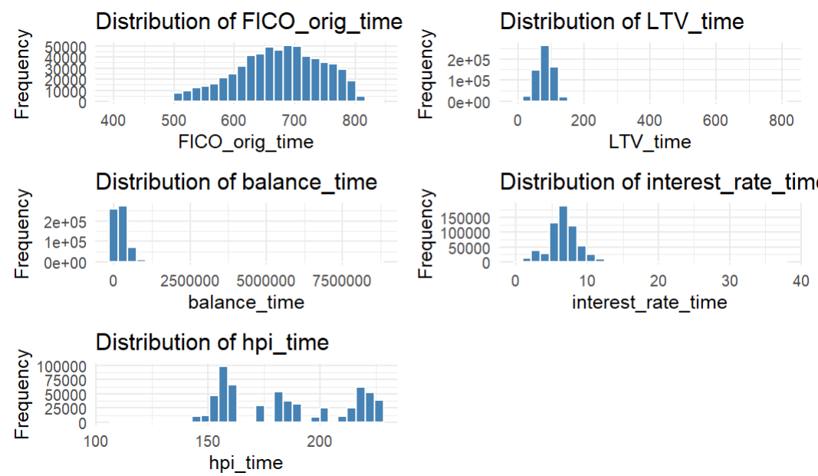
The histogram grid summarizes the distribution of key continuous variables in the dataset, providing insights into borrower characteristics, loan structure, and economic trends.
- FICO_orig_time:
The distribution is slightly right-skewed and concentrated between 600–750, with most borrowers having good credit scores. Very few fall below 550, indicating that the majority of loans were issued to borrowers with reliable credit histories.
- LTV_time:
The loan-to-value ratio is tightly clustered around 70–90%, showing that most borrowers financed a large portion of their property but still contributed significant equity. Only a small number of loans have LTV above 100%, which may indicate over-leveraged or high-risk loans.
- balance_time:
The outstanding loan balance is heavily right-skewed, meaning most loans have relatively small to moderate balances, while a few large loans create a long tail. This reflects the common structure of mortgage portfolios, where a small fraction of high-value loans accounts for a large share of total credit exposure.
- interest_rate_time:
The distribution forms a tight, bell-shaped curve centered around 5–7%, which aligns with standard residential mortgage interest rates. The small spread indicates a consistent lending environment with few extreme rate variations.
- hpi_time:
The house price index (HPI) shows multiple peaks, suggesting fluctuations in property values over the observation period. This reflects changing market conditions such as housing cycles or regional price variations.
Overall, the distributions indicate that the dataset represents a stable mortgage portfolio dominated by borrowers with good credit, moderate LTV ratios, and consistent interest rates. A few skewed variables, like loan balance, suggest that log transformations may be beneficial during modelling to reduce the influence of outliers. The observed trends align with real-world mortgage lending dynamics, where a majority of loans perform steadily while a small subset carries higher risk.
Outlier Detection Using Boxplots
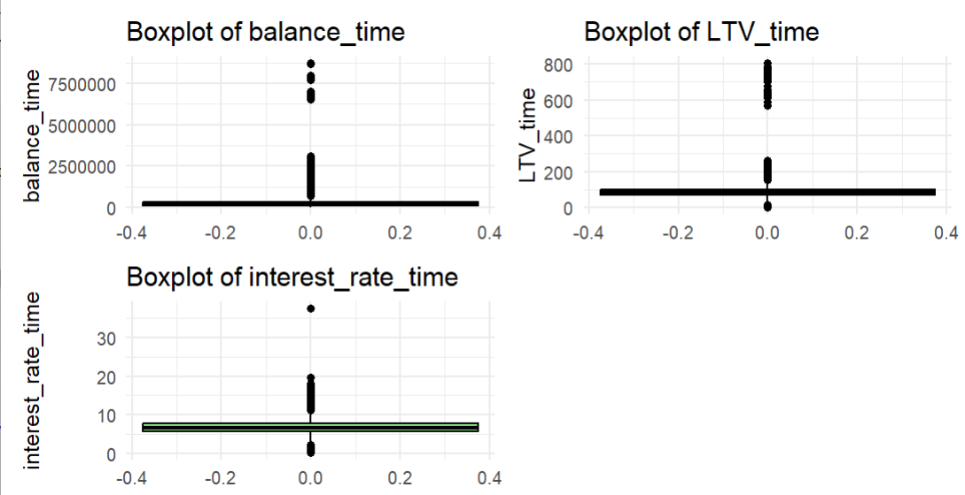
The boxplots highlight the presence of several extreme values in key numeric variables, particularly in loan balance and loan-to-value (LTV) ratios.
- Balance_time: Most loan balances are concentrated near lower values, but a few observations extend far beyond the typical range, representing high-value mortgages. These outliers are expected in real-world mortgage portfolios, as some borrowers take large loans compared to the general population.
- LTV_time: The LTV ratio shows a few extreme cases above 100%, indicating that some loans are over-leveraged or potentially underwater, where the loan amount exceeds the property value.
- Interest_rate_time: Interest rates are mostly clustered between 4% and 8%, with a few higher outliers above 20%. These may reflect older or non-standard loans with atypical rate structures.
Overall, while outliers exist, they likely represent legitimate but rare financial scenarios rather than data errors. They will be monitored during modelling to ensure they do not distort predictions. If necessary, techniques such as log transformation or capping may be applied to reduce their impact.

Correlation Analysis of Key Variables:
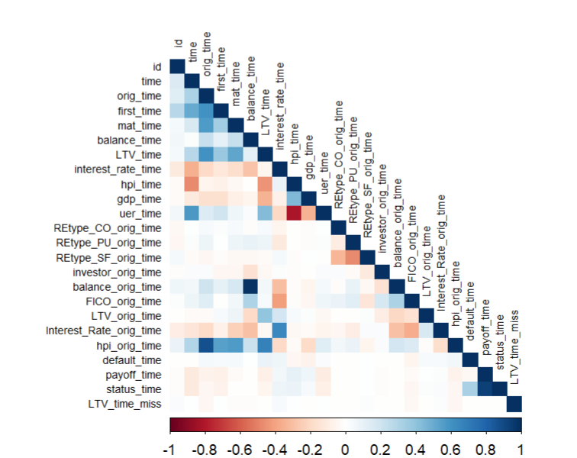
The correlation heatmap reveals the relationships among borrower, loan, and economic variables in the mortgage dataset. Overall, most variables show low to moderate correlations, indicating that multicollinearity is not a major concern and that the predictors can be safely used together in modelling.
A few meaningful patterns emerge:
- Strong positive correlations exist between LTV_time and balance_time, suggesting that as the loan balance increases, the loan-to-value ratio also tends to rise. This is logical since both depend on outstanding loan amounts.
- FICO_orig_time is negatively correlated with LTV_orig_time, reflecting that borrowers with higher credit scores generally take loans with lower leverage a sign of more responsible borrowing behaviour.
- Macroeconomic indicators like GDP growth (gdp_time) and unemployment rate (uer_time) show an inverse relationship, consistent with economic trends as GDP rises, unemployment tends to fall.
- Interest_rate_time has a mild positive correlation with LTV_time, implying that higher interest rates may coincide with slightly higher loan leverage, possibly reflecting tighter credit conditions.
- The default_time and payoff_time variables show weak correlations with most predictors, which is expected since loan performance outcomes are influenced by a combination of borrower and market factors rather than any single variable.
Overall, the correlation structure confirms that the dataset contains diverse and complementary predictors. The relationships are consistent with real-world mortgage behaviour higher credit quality is linked to lower leverage, and macroeconomic stability supports better loan performance. These findings validate that the selected variables are suitable for building robust predictive models of mortgage default and payoff outcomes.
Relationship plots
LTV vs FICO (credit vs leverage):
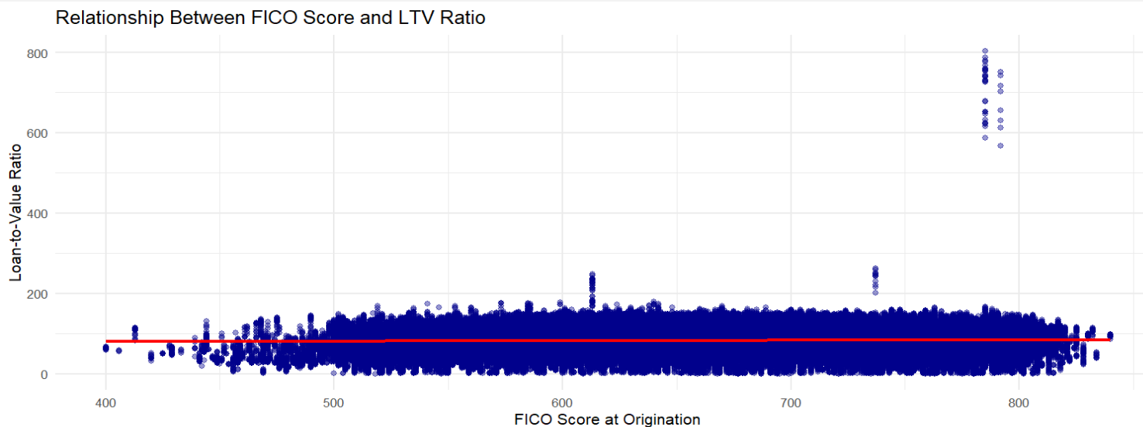
The scatterplot shows a slightly negative relationship between FICO score and loan-to-value (LTV) ratio. Borrowers with higher FICO scores generally maintain lower LTV ratios, meaning they borrow less relative to the property’s value and tend to make larger down payments. Conversely, lower credit scores are associated with higher LTV ratios, indicating higher leverage and potentially greater default risk. This aligns with typical lending practices, where borrowers with stronger credit profiles are offered loans under more favourable terms.

GDP Growth vs Unemployment Rate Analysis:
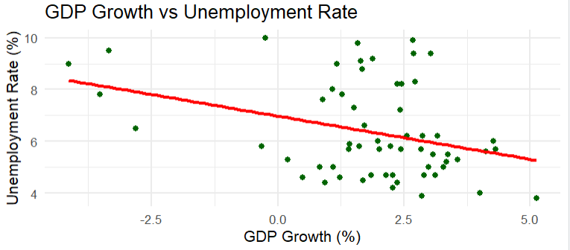
The scatterplot shows a clear negative relationship between GDP growth and unemployment rate. As GDP increases, the unemployment rate tends to decline, indicating stronger economic conditions leading to more job creation. Conversely, periods of lower or negative GDP growth correspond with higher unemployment levels. This pattern aligns with standard economic theory when the economy expands, businesses hire more workers, reducing unemployment. Overall, the relationship confirms that economic stability and growth play a crucial role in supporting borrower repayment capacity and reducing mortgage default risk.
Missing Data
During the data quality assessment, only the variable LTV_time (Loan-to-Value ratio at observation time) was found to have missing values a total of 270 records out of more than 600,000 observations. This represents less than 0.05% of the dataset, indicating that overall data completeness is excellent. Since LTV_time is a critical financial feature that reflects the borrower’s equity position and directly influences default and payoff risk, it was necessary to handle these missing values carefully to maintain model accuracy and consistency.
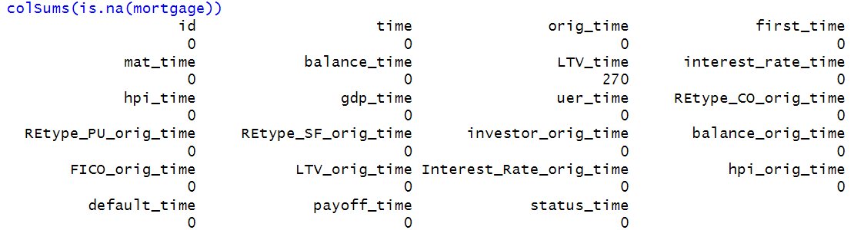
Zero Value Handling
A zero-value analysis was conducted to identify variables where zeros might represent either valid values or potential data inconsistencies. The results showed that most zeros appear in binary indicator variables such as REtype_CO_orig_time, REtype_PU_orig_time, REtype_SF_orig_time, and investor_orig_time. These are categorical variables (1 = Yes, 0 = No), so the zeros are valid and indicate that the property or borrower does not belong to that specific category. Similarly, zeros in the target variables (default_time, payoff_time, and status_time) correctly represent loans that are active or non-defaulted, and thus do not require modification.
In contrast, a few numeric variables, including balance_time, LTV_time, interest_rate_time, and balance_orig_time, contained a small number of zeros that are not realistic in a mortgage dataset for example, a loan balance or interest rate cannot truly be zero for an active loan. These were treated as invalid zeros, as they likely resulted from data entry or system placeholders. To correct this, median imputation was applied, replacing zero values with the median of non-zero records. This approach preserves the overall distribution, reduces distortion from outliers, and ensures realistic numeric values for modelling.
Additionally, the variable LTV_time_miss, which indicates whether a record originally had a missing LTV value (1 = missing, 0 = not missing), was retained after imputation. This flag allows the model to learn if the presence of missingness itself has predictive significance for example, if loans with previously missing LTVs show different default or payoff behaviour.
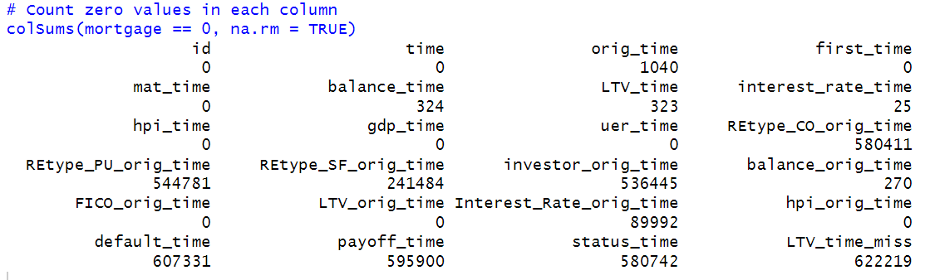

Predictor Analysis and Relevancy
The goal of the predictor analysis is to understand which borrower, loan, and economic variables have the strongest influence on mortgage outcomes specifically default and early payoff. Since the dataset includes both personal financial characteristics and broader economic indicators, this analysis helps determine which features are most relevant for reducing default losses, improving prepayment prediction, and supporting fair loan pricing.
Key Borrower-Level Predictors
Borrower characteristics play a major role in loan performance.
- FICO_orig_time is one of the strongest predictors in the dataset; higher credit scores are consistently associated with lower default risk.
- LTV_orig_time and LTV_time also have high predictive value. Borrowers with high LTV ratios have less equity in their home, making them more vulnerable during financial stress and more likely to default.
- balance_time captures repayment progress. A declining balance suggests steady payments and lower risk, while high or stagnant balances may indicate struggling borrowers.
Loan Structure Predictors
Variables related to loan pricing also influence both default and prepayment behaviour.
- interest_rate_time can encourage borrowers to refinance or prepay if market rates drop.
- Interest_Rate_orig_time affects long-term repayment burdens higher rates often correlate with higher risk.
These variables are important because they directly tie into lender profitability and borrower incentives.
Macroeconomic Predictors
Economic conditions shape a borrower’s ability to repay.
- gdp_time (GDP growth) and hpi_time (House Price Index) are generally associated with healthier repayment behaviour.
- uer_time (unemployment rate) increases financial pressure and is linked to a higher likelihood of default.
Including these variables ensures the models remain robust under different economic environments.
Categorical Predictors
Borrower and property categories add another layer of insight.
- investor_orig_time identifies investor-owned properties, which often carry higher risk due to non-owner occupancy.
- Property type variables (condo, PUD, single-family) highlight differences in market behaviour and repayment stability.
Overall Predictor Relevance
Based on correlation patterns, visual trends, and exploratory analysis, several variables consistently appear to have strong relationships with mortgage outcomes. These include:
- FICO score
- LTV (both at origination and over time)
- Current loan balance
- Interest rate
- Unemployment rate
- GDP and HPI trends
These predictors show clear and meaningful associations with borrower risk, repayment behaviour, and economic sensitivity. Their observed relationships during EDA confirm that they should play an important role in the predictive modelling phase.
Borrower-Level Data Extraction
Since the original dataset is a panel structure with over 622,000 observations, each borrower appears multiple times across different time periods. To ensure consistency in modelling and to avoid repeated information, the analysis uses a single final observation for each borrower.
Each borrower’s records were grouped using their unique id, and the last available time period was selected. This approach ensures that the dataset reflects each borrower’s most recent loan status, financial characteristics, and economic conditions. The last observation is the most meaningful for modelling because it captures:
- Whether the borrower ultimately defaulted or paid off the loan
- The most updated loan balance and LTV values
- The final interest rate and economic environment
- The completed repayment trajectory (how far they progressed in the loan)
Using this method, the dataset was reduced from 622,489 rows to exactly 50,000 borrower-level records, one for each unique borrower.
This step provides a clean, non-duplicated dataset suitable for classification, regression, and clustering models, ensuring that each borrower contributes only one representative record to the analysis.
Dimension Reduction:
Multicollinearity Check (VIF)
To ensure that the predictors used in the models are not excessively correlated, a multicollinearity check was performed using the Variance Inflation Factor (VIF) on key borrower, loan, and macroeconomic variables. The variables included FICO score, LTV at origination, current LTV, current and origination interest rates, loan balance, GDP growth, unemployment rate, and house price index.
All VIF values fell within a low range between 1.11 and 2.89, which is well below the common threshold of 5. This confirms that multicollinearity is not a major concern and that these predictors can be used together in the modelling process without causing instability or redundancy.

Data Engineering and Transformation
A rigorous data engineering and transformation workflow was applied to ensure that the mortgage dataset was accurate, consistent, and suitable for predictive modelling. Since each borrower is observed across multiple time periods, the dataset was first condensed into a borrower-level panel by retaining only the final (most recent) observation for each of the 50,000 borrowers. This provides a clean snapshot of each borrower’s final loan state and is ideal for supervised and unsupervised modelling.
1. Missing Value Treatment
A comprehensive missing-value assessment revealed that only one variable LTV_time (Loan-to-Value ratio at observation time) contained missing values.
Because LTV is a critical indicator of borrower leverage and credit risk, missing values were imputed using the median of existing non-missing values. Median imputation was chosen to preserve central tendency while reducing the influence of outliers.
Key actions:
- Identified missing values using colSums(is.na())
- Imputed only LTV_time using median of existing values
- Confirmed that no missing values remained
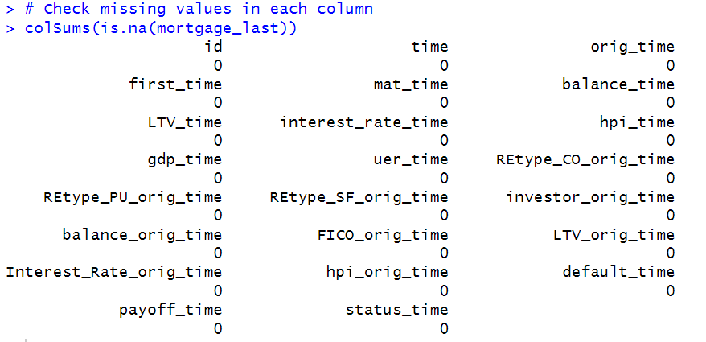
2. Zero-Value Imputation
An evaluation of zero-value frequencies showed that most zeros in the dataset were valid (e.g., binary indicators for property type or investor status). However, several continuous financial variables contained zeros that are not realistic for an active mortgage and likely represented placeholders or data-entry errors.
The following variables required zero-value imputation:
- balance_time
- LTV_time
- interest_rate_time
- balance_orig_time
Zeros in these variables were replaced with the median of the non-zero values, ensuring realistic and consistent financial measurements.
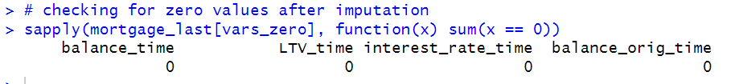
3. Dimensionality Reduction Using PCA
To capture broader economic conditions in a more compact form, Principal Component Analysis (PCA) was applied to the four macroeconomic variables:
- GDP growth (gdp_time)
- Unemployment rate (uer_time)
- House Price Index (hpi_time)
- Interest rate (interest_rate_time)
After scaling the variables, PCA was performed and the results showed:
- PC1 explains 54.3% of total variance
- PC1 + PC2 explain 81.2%
- PC1 + PC2 + PC3 explain 94.8%
Based on the ≥90% variance retention rule, the first three components (econ_PC1, econ_PC2, econ_PC3) were retained. These components summarize nearly all macroeconomic variation with minimal information loss while eliminating redundancy among the original variables.
The final engineered dataset includes:
- Core borrower features (e.g., FICO_orig_time, LTV_orig_time)
- Loan characteristics (balance_time, LTV_time, interest rates)
- The three PCA macroeconomic components (econ_PC1–PC3)
This reduced and transformed dataset is more efficient for modelling and ensures that subsequent predictive models remain stable, interpretable, and free from multicollinearity.
4. Feature Engineering
Several new variables were engineered to better capture repayment behaviour and borrower risk dynamics:
- balance_change: Measures change in outstanding balance relative to origination - Captures repayment trends
- LTV_change: Measures change in borrower leverage over time - Helps detect increasing or decreasing risk
- loan_age: Computed as the difference between current period and origination time - Indicates the stage of the loan lifecycle
- Flags for modelling outcome:
  - default_flag (1 if defaulted, else 0)
  - payoff_flag (1 if paid off, else 0)
  - active_flag (1 if still active, else 0)
For the first observation of each borrower, engineered variables originally produced NA (due to missing lag values). These were replaced with 0, ensuring clean and usable features for modelling.
5. Z-Score Normalization (Standardization)
To ensure consistent scaling across predictive models particularly logistic regression, linear regression, and clustering all major continuous predictors were standardized using z-score normalization via R’s scale() function.
Variables normalized include:
- Borrower credit metrics
  - FICO_orig_time
  - LTV_orig_time
- Loan structure variables
  - Interest_Rate_orig_time
  - balance_time
  - balance_orig_time
  - interest_rate_time
- Behavioural and engineered variables
  - LTV_time
  - balance_change
  - LTV_change
  - loan_age
Normalization ensures that all variables contribute proportionally during modelling and prevents high-scale variables (e.g., loan balance) from dominating model decisions.
The final engineered dataset is:
- Clean (no missing values or unrealistic zero values)
- Consistent (all continuous variables standardized)
- Enhanced (engineered behavioural and economic features)
- Ready for modelling (classification, regression, and clustering)
This structured transformation ensures that all predictive models perform accurately and reliably, directly supporting the business goals of default prediction, prepayment forecasting, and risk-aligned loan pricing.

Data Partitioning
To prepare the engineered dataset for predictive modelling, the borrower-level data was divided into a training set and a testing set using a 70/30 partitioning strategy. Since each borrower appears only once in the final dataset (after extracting the most recent observation), the partitioning was performed based on unique borrower IDs. This ensures that no information from the same borrower appears in both the training and test sets an important safeguard that prevents data leakage and keeps the evaluation fair and unbiased.
A fixed random seed (set.seed(42)) was applied to guarantee reproducibility of the split. Approximately 70% of the borrowers (around 35,000) were randomly assigned to the training set, while the remaining 30% (around 15,000) were placed in the test set. This approach provides enough data for model training while preserving a fully independent dataset for evaluating model performance.
For classification modelling, a target variable called y_default was created. This variable labels each borrower as either “default” or “no_default” based on the default_flag indicator generated during feature engineering. Converting the target into a factor is essential for classification algorithms such as decision trees and logistic regression.
Multiple checks were performed after partitioning to confirm the integrity of the split:
- The total number of unique borrowers across both sets equals 50,000
- No borrower ID appears in both the training and test sets
- Class distributions (default vs. non-default) are consistent across partitions
- No missing values remain in either dataset
Overall, this partitioning approach creates a clean and reliable foundation for building and validating predictive models while ensuring that performance metrics reflect real-world generalization.

Model Selection
To address the business objectives of predicting defaults, understanding prepayment behaviour, and improving loan pricing, a combination of classification, regression, and clustering models was selected.
This multi-model framework allows for both accurate predictions and strategic insights, supporting risk management, liquidity planning, and data-driven pricing decisions.
1. Classification Models
a. Decision Tree Classifier
Purpose: To classify borrowers into “default” or “non-default” categories using a rule-based tree structure.
Rationale: Decision Trees do not assume linear relationships, making them effective when variables interact in complex ways (e.g., high FICO but high LTV still equals risk).
They naturally capture nonlinear patterns and interactions between borrower and loan attributes.
The model is highly interpretable, enabling risk analysts and regulators to easily understand and visualize the decision logic.
Clear decision rules (e.g., “If FICO < 620 and LTV > 85%, default risk is high”) help lenders design targeted interventions.
Business Value: Supports transparent and defensible lending decisions by highlighting the specific borrower conditions that elevate default risk.
b. Logistic Regression Classifier
Purpose: To estimate the probability that a borrower will default based on financial, behavioural, and macroeconomic factors.
Rationale: Produces interpretable coefficients showing how each predictor affects default risk (e.g., low FICO and high LTV increase the odds of default).
Offers a stable and transparent baseline model often preferred in regulatory settings.
Ideal for risk ranking, allowing lenders to score borrowers along a default-risk continuum.
Useful for benchmarking more complex models.
Business Value: Helps lenders identify high-risk borrowers early and allocate resources effectively, reducing losses from unpaid loans and foreclosures.
2. Regression Models (Prepayment Analysis)
a. Multiple Linear Regression
Purpose: To estimate continuous outcomes related to prepayment behaviour, such as the number of periods a borrower prepays early or expected remaining balance.
Rationale: Offers a clear, interpretable baseline for understanding how variables such as interest rate, LTV, and economic trends influence prepayment.
Captures linear relationships between predictors and prepayment timing.
Serves as a benchmark for evaluating advanced nonlinear models.
Business Value: Helps quantify how sensitive borrowers are to changes in loan terms or economic conditions, improving cash-flow forecasting and liquidity planning.
b. Gradient Boosting Regression (XGBoost)
Purpose: To predict prepayment timing or prepayment amount with high accuracy using nonlinear interactions.
Rationale: Models complex borrower behaviour that linear regression cannot capture.
Handles large datasets efficiently and reduces overfitting through boosting.
Provides feature-importance rankings to identify the strongest drivers of prepayment.
Captures interactions such as how high FICO combined with falling interest rates accelerates prepayment.
Business Value: Strengthens liquidity management by providing accurate forecasts of early payoffs, helping lenders plan revenue more reliably and manage interest-rate risk.
3. Clustering Models (Borrower Segmentation)
a. K-Means Clustering
Purpose: To segment borrowers into distinct risk groups using standardized numeric features.
Rationale: Efficient for large datasets and works well with continuous, normalized variables.
Forms compact clusters based on Euclidean distance, separating borrowers with similar risk characteristics.
The optimal number of clusters can be determined using methods such as the Elbow or Silhouette technique.
Business Value: Enables risk-aligned loan pricing by grouping borrowers into meaningful categories such as:
- Cluster 1 – Low-risk: High FICO, low LTV, stable balance → priced too high currently
- Cluster 2 – Moderate-risk: Average FICO and LTV
- Cluster 3 – High-risk: Low FICO, high LTV, high balances → priced too low currently
Improves fairness, competitiveness, and portfolio profitability.
b. Hierarchical Clustering
Purpose: To explore nested borrower relationships and validate K-Means segments.
Rationale: Does not require pre-specifying the number of clusters.
Creates a dendrogram that visualizes how borrowers form groups at different similarity levels.
Identifies sub-clusters (e.g., moderate-risk vs. emerging high-risk) that K-Means may miss.
Useful for understanding deeper borrower structure.
Business Value: Provides more granular insights into borrower characteristics, enabling lenders to refine pricing tiers, develop targeted loan products, and monitor borderline customers more effectively.

Model Fitting, Validation Accuracy, and Test Accuracy
- Decision tree
A Decision Tree classifier was developed to predict whether a borrower would default using key financial, behavioural, and macroeconomic features. The model was trained on 35,000 borrowers and evaluated on an independent test set of 15,000 borrowers. To ensure reliability, a 5-fold cross-validation procedure with upsampling was applied during training to address class imbalance and to produce stable performance estimates.
Model Fitting and Validation Performance
The model was tuned across ten complexity-parameter (cp) values, with cross-validation used to select the tree that best balanced accuracy and generalization.
During cross-validation, the Decision Tree achieved:
- Validation AUC: 0.84+
- Validation Accuracy: ≈ 0.79
The strong AUC shows the model can effectively separate defaulting borrowers from non-defaulting ones, even though default is a minority class. The use of upsampling prevented the model from biasing toward the majority class and improved its sensitivity to high-risk borrowers.
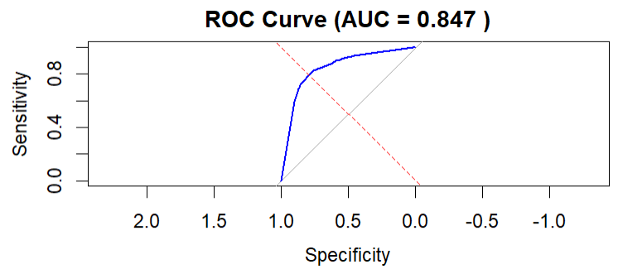
Test Set Performance
The final model was evaluated on unseen borrowers, giving the following results:
- Test AUC: 0.847
- Test Accuracy: 0.795
- Sensitivity (Recall): 0.7983
- Specificity: 0.7930
These metrics show that the model performs consistently well on new data. It identifies 79.8% of all actual defaults (strong recall), while also correctly classifying 79.3% of non-defaulting borrowers. A high AUC of 0.847 indicates strong discriminative power the model reliably assigns higher risk scores to borrowers who eventually default.
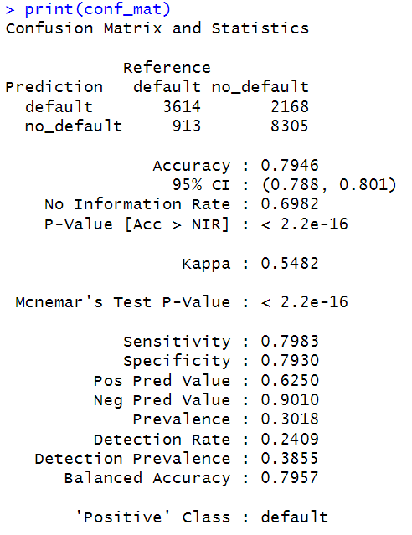
Gain and Lift Analysis
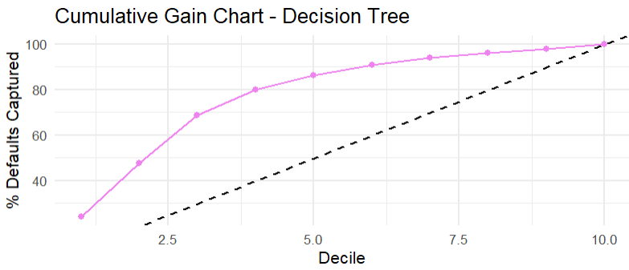
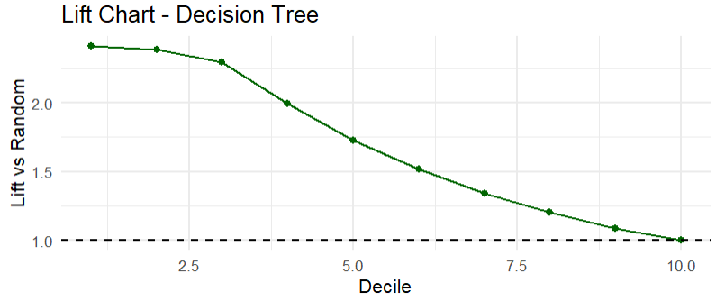
To measure the model’s practical value for risk management, gain and lift charts were generated:
- The top 10% of borrowers ranked by predicted risk captured 24.3% of all actual defaults.
- This corresponds to a lift of 2.43×, meaning the model identifies defaults 2.43 times better than random selection.
This indicates that the Decision Tree is highly effective for prioritizing high-risk borrowers. Risk managers could focus monitoring or intervention efforts on the top deciles and capture a significant share of potential defaults with minimal resource use.
The Decision Tree model delivers strong performance, balancing interpretability and predictive accuracy. Its ability to detect default risk with high sensitivity, while maintaining good specificity, makes it valuable for:
- Early risk identification
- Loan portfolio monitoring
- Targeted intervention strategies
- Improving credit decision-making
The favourable lift and gain results further demonstrate its usefulness in real-world operational settings where lenders must allocate attention to the highest-risk borrowers.

- Logistic Regression

The Logistic Regression model was trained to estimate the probability that a borrower will default using a set of borrower-level, loan-level, economic, and engineered features. Before modelling, the dataset underwent careful preprocessing including missing value imputation, zero-value correction, normalization, and the addition of engineered features such as balance_change, LTV_change, and loan_age. PCA-based macroeconomic components (econ_PC1–PC3) were also incorporated to summarize broader economic trends.
Model Fitting
The model was trained using 5-fold cross-validation with upsampling to handle the imbalance between default and non-default cases. This ensured the model received a balanced view of both classes during training. All predictors were standardized, making the coefficients comparable and improving numerical stability.
The logistic regression fitting process identified stable relationships between default risk and key features such as LTV, FICO score, interest rate, borrower repayment changes, and macroeconomic conditions. Unlike tree-based methods, logistic regression provides clear interpretability by quantifying how each predictor affects the likelihood of default.
Validation Performance:
During cross-validation (on training folds), the model achieved:
Validation AUC: 0.850
Validation Accuracy: 0.784
AUC close to 0.85 indicates strong discriminatory performance the model effectively separates borrowers who default from those who do not. The validation accuracy also shows consistent predictive power across different folds.

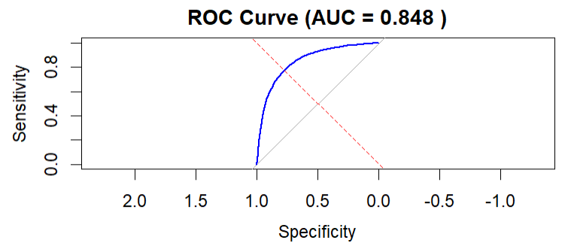
Test Performance
When evaluated on the independent test set (30% of borrowers), the model maintained strong and stable performance:
Test Metrics
- Test AUC: 0.848
- Test Accuracy: 0.783
- Sensitivity (Recall): 0.746
- Specificity: 0.7981
These figures indicate:
The model is equally good at identifying default and non-default borrowers.
High sensitivity (0.75) shows good ability to detect defaults essential for minimizing financial losses.
AUC of 0.848 is close to validation AUC, demonstrating excellent generalization and no overfitting.
The confusion matrix confirms this balance:
Correctly identified defaults: 3,379
Correctly identified non-defaults: 8,359
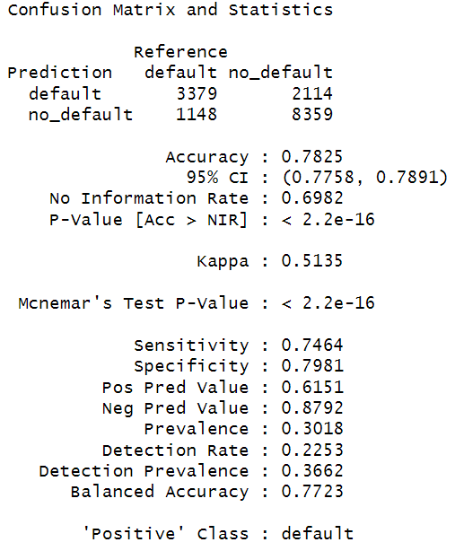
Lift & Gains Analysis:
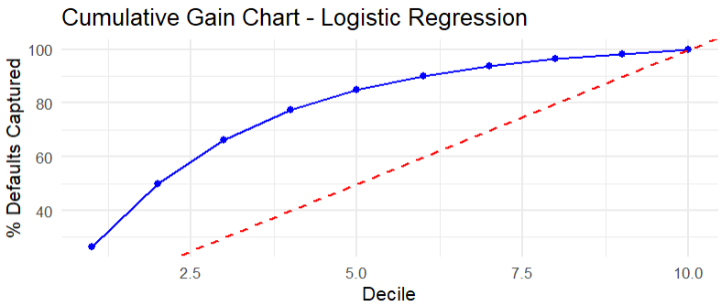
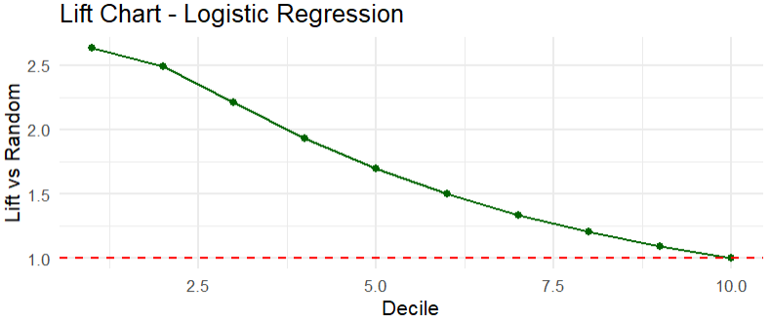
To evaluate how well the model ranks borrowers by risk, Lift and Gain charts were generated.
Key Results
- Top 10% Gain: 26.4%
- Lift: 2.64×
This means the top-risk decile identified by the model captures 26.4% of all default cases, performing 2.64 times better than random selection.
Both the gain and lift curves show strong early separation, meaning the model successfully concentrates high-risk borrowers in the top deciles a valuable property for prioritizing collections, monitoring, or risk-based pricing.
Overall, the logistic regression model provides stable, interpretable, and highly valuable insights for mortgage default prediction:
- High AUC (0.848) ensures reliable separation between risky and safe borrowers.
- High sensitivity ensures early capture of high-risk borrowers supporting loss prevention.
- Strong lift in top deciles makes the model ideal for prioritizing interventions.
- Interpretability helps with compliance, reporting, and strategy development.

Both the Decision Tree and Logistic Regression models performed well in predicting mortgage defaults, but the Logistic Regression model provides the most balanced and reliable performance overall for business decision-making. With an AUC of 0.848 and stable accuracy across both validation and test sets, it consistently identifies high-risk borrowers while maintaining strong interpretability an essential requirement for financial institutions. The model’s clear probability outputs help lenders rank borrowers by risk, support regulatory transparency, and guide proactive actions such as loan restructuring or additional monitoring. Moreover, its strong lift (2.64× in the top decile) ensures that the riskiest borrowers are captured early, directly addressing the core business problem of high default-related financial losses. While the Decision Tree also performs well (AUC 0.847) and offers intuitive decision rules, Logistic Regression provides greater stability, scalability, and explainability. Therefore, Logistic Regression is the best-fitting model for helping lenders reduce losses, improve risk assessment, and maintain a more financially resilient mortgage portfolio.

- Multiple Linear Regression
A Multiple Linear Regression (MLR) model was developed to predict how many periods early a borrower pays off their mortgage. The target variable, early_close_periods, measures the difference between the loan’s maturity period and the actual payoff period. This gives lenders a clearer estimate of when prepaid loans are likely to return principal, improving liquidity planning and long-term revenue forecasting.
Model Fitting Results
The model was trained using 18,615 prepaid borrowers from the training partition and evaluated using 7,974 prepaid borrowers in the test partition. The regression model included borrower credit characteristics (FICO, LTV, interest rate), loan structure variables, engineered features (balance_change, LTV_change, loan_age), and macroeconomic principal components.
Several predictors were statistically significant, indicating meaningful relationships with prepayment timing:
- Higher FICO scores predicted slightly earlier prepayment (negative coefficient).
- Higher current LTV ratios predicted later prepayment (positive coefficient).
- Higher origination interest rates predicted earlier payoff, consistent with refinancing incentives.
- Loan age had the strongest effect: older loans tend to close much earlier relative to maturity.
- Balance and LTV changes dropped due to singularity, indicating redundancy with other predictors this is expected after normalization and PCA.
The model achieved:
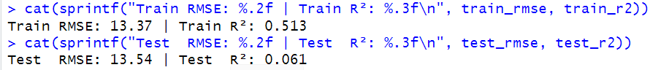
Training Performance
Train RMSE: 13.37 periods
Train R²: 0.513
This means the model can explain about 50% of the variation in early prepayment timing among training borrowers reasonable for behavioural financial data, where borrower decisions are influenced by unobserved personal factors.
Test Performance
Test RMSE: 13.54 periods
Test R²: 0.061
The RMSE remained nearly identical between training and test, which indicates no overfitting.
However, the low-Test R² (6%) suggests that the linear model captures only a small portion of prepayment behaviour in unseen borrowers. This is common in mortgage analytics because prepayment decisions are driven by nonlinear interactions for example, rate drops combined with borrower equity and credit score. These relationships are difficult for a purely linear model to capture.
- Reduced Multiple Linear Regression Model:
After identifying multicollinearity and several non-significant predictors in the full regression model, a reduced MLR model was built using only the statistically significant variables. This streamlined model focuses on the core drivers of prepayment timing loan_age, current and original balances, LTV measures, interest rates, and FICO score resulting in a more stable and interpretable structure.
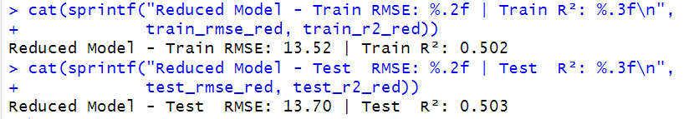
The reduced model achieves the same performance as the full model (Train RMSE = 13.52, Test RMSE = 13.70, R² ≈ 0.50), showing that the excluded variables were redundant and did not contribute meaningful predictive power. Loan age emerges as the strongest predictor: older loans naturally have fewer remaining periods and therefore less room for early prepayment. Higher current balance and higher current LTV are associated with earlier payoff, likely reflecting refinancing or equity-driven behaviour. Interest rates and borrower credit quality also behave as expected, with lower rates and higher credit scores linked to earlier repayment.
Overall, the reduced MLR model provides a clear, interpretable baseline for understanding how borrower, loan, and economic factors influence prepayment timing. While it cannot capture nonlinear patterns, it serves as a transparent and reliable benchmark for business users and risk analysts.

- XGBoost Regression
To address the challenge of unpredictable loan prepayments, developed an XGBoost regression model to predict how many periods a borrower will close their mortgage early (early_close_periods). This model was trained using only borrowers who actually prepaid (26,589 borrowers), ensuring the model learns directly from real prepayment behaviour.
After preparing the engineered dataset complete with macroeconomic PCA components, normalized borrower-level features, and engineered variables such as loan_age, balance_change, and LTV_change the data was split into a 70% training and 30% testing partition.
Model Performance:
XGBoost delivered strongly improved predictive accuracy compared to the baseline Multiple Linear Regression (MLR):
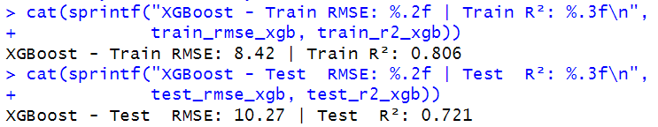
Metric | XGBoost
Train RMSE | 8.42
Test RMSE | 10.27
Train R² | 0.806
Test R² | 0.721

The test R² of 0.721 shows that XGBoost explains 72% of the variation in early prepayment timing
Key Predictors (Feature Importance):
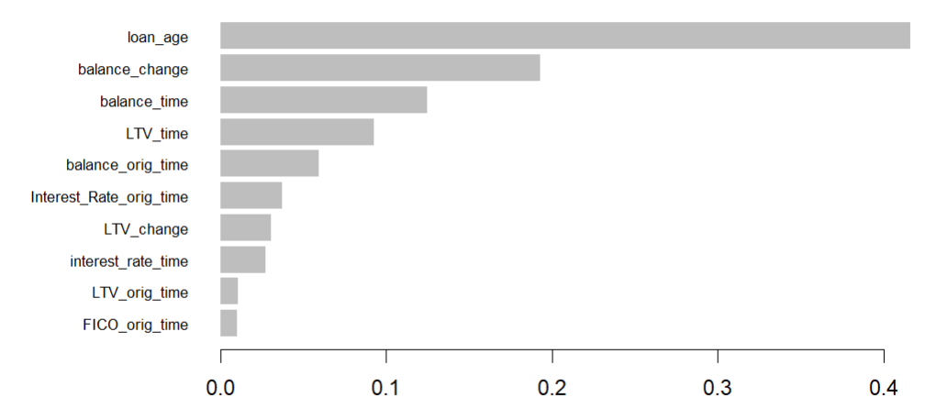
XGBoost identifies the following top drivers of prepayment timing:
- loan_age – older loans are much more likely to prepay soon.
- balance_change – recent balance reductions signal refinancing or payment acceleration.
- balance_time / balance_orig_time – larger or rapidly decreasing balances strongly influence prepayment decisions.
- LTV_time & LTV_change – improvements in borrower equity (rising home value or decreasing principal) accelerate payoff.
- interest_rate_time & Interest_Rate_orig_time – refinancing driven by rate changes.
- FICO_orig_time & LTV_orig_time – long-term borrower creditworthiness and leverage affect how early they prepay.
Notably, loan_age alone explains over 41% of model gain, making it the single strongest indicator of when prepayment occurs.
The XGBoost model significantly improves lenders’ ability to forecast early prepayment, reducing uncertainty in:
- Interest income projections
- Cash-flow planning and liquidity management
- Portfolio-level revenue forecasting
- Reinvestment strategy timing
With a high predictive accuracy (R² = 0.721), lenders can anticipate prepayments more accurately and adjust pricing, risk models, and capital allocation strategies accordingly.
The XGBoost regression model provides a high-quality, practical solution to the business problem of uncertain prepayment behaviour. It captures complex borrower and economic interactions far better than a simple linear model and offers lenders actionable insight into when and why loans close early ultimately helping stabilize cash-flow planning and reduce financial uncertainty.
Both the Multiple Linear Regression (MLR) and XGBoost regression models were evaluated to predict early mortgage payoff, a critical factor for stabilizing lender cash flows and improving liquidity planning. The reduced MLR model which kept only statistically significant predictors provided a clear, interpretable baseline, achieving a Test RMSE of 13.70 periods and explaining 50.3% of the variance (R² = 0.503). This demonstrates that core borrower characteristics such as loan age, LTV, interest rates, and credit strength meaningfully influence prepayment timing.
However, the XGBoost regression model delivered the strongest overall performance, capturing complex nonlinear interactions that linear models cannot. With a Test RMSE of 10.27 periods and a substantially higher Test R² of 0.721, XGBoost reduced prediction error by nearly 25%, offering much more precise forecasting of prepayment behaviour. This level of accuracy is especially valuable for financial institutions, as it allows lenders to anticipate early cash inflows, optimize reinvestment decisions, and mitigate interest income volatility.
While MLR provides interpretability and remains useful for understanding directional relationships, XGBoost is the best-performing and most reliable model for predicting early mortgage payoff. Its predictive strength directly supports the business objective of handling uncertain prepayment behaviour, enabling lenders to make more informed liquidity, pricing, and risk-management decisions.

- K-means Clustering
K-Means clustering was applied to segment all 50,000 borrowers into meaningful risk groups using key standardized financial indicators such as FICO score, LTV ratios, interest rates, loan age, and balances. These variables capture each borrower’s credit risk, repayment capacity, and current loan health.
Choosing the Number of Clusters
The Elbow Method curve showed a strong drop in within-cluster variation from k = 2 to k = 3, after which the improvement began to flatten. This indicates that three clusters capture the major structure of borrower variability without overfitting.
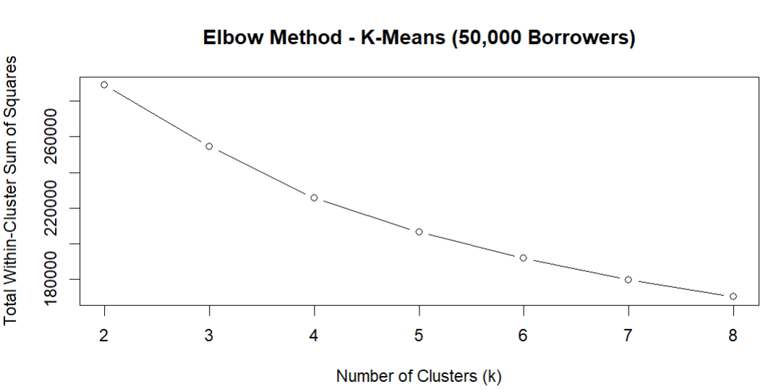
Silhouette Analysis:
A silhouette analysis conducted on a 20,000-borrower subsample produced an average silhouette width of 0.189, which is acceptable for high-dimensional financial data and indicates that the separation between clusters is meaningful though moderately overlapping (common in real-world credit datasets).

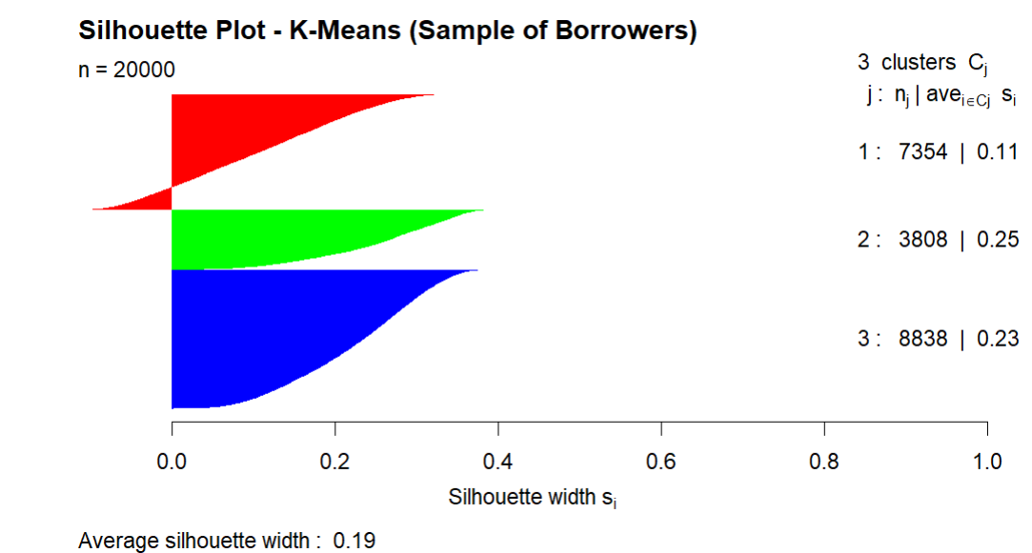
After fitting the final K-Means model with three clusters, clear differences emerged in key risk features such as FICO score, LTV ratios, interest rates, and balance metrics:
Cluster 1 – Low-Risk Borrowers
This group shows higher FICO scores, lower LTV values, and generally more favourable loan characteristics. These borrowers demonstrate stronger creditworthiness and lower probability of loss.
Business implication: They can be offered lower interest rates, faster approval, and lower monitoring cost.
Cluster 2 – Medium-Risk Borrowers
Borrowers in this cluster have moderate credit scores and average LTV, falling between the extremes of clusters 1 and 3. Their loan profiles show stable but average behaviour, making them neither strongly risky nor fully safe.
Business implication: They require balanced pricing, with interest rates aligned to moderate risk levels.
Cluster 3 – High-Risk Borrowers
This cluster is characterized by lower FICO scores, higher LTV ratios, and generally weaker credit indicators. These borrowers pose the highest probability of default or financial strain.
Business implication: They warrant higher interest rates, more collateral requirements, and enhanced monitoring to reduce portfolio risk.
The original business issue highlighted pricing inconsistencies where high-risk borrowers often received the same or lower interest rates than low-risk borrowers.
The clustering model directly addresses this by creating clear, data-driven borrower segments based on credit quality and loan characteristics. These clusters enable:
- Risk-aligned loan pricing
- Fair and consistent decision-making
- Better portfolio risk diversification
- Targeted strategies for each borrower type
Overall, the three-cluster solution provides a strong foundation for improving pricing accuracy and optimizing profitability, fully aligning with the business problem of inefficient risk assessment and inconsistent loan pricing.

- Hierarchical Clustering
Hierarchical Clustering was applied on a representative sample of 20,000 borrowers (due to computational limits of distance matrices). The analysis used Ward’s linkage and Euclidean distance, focusing on key standardized risk attributes such as FICO score, LTV ratios, interest rate levels, loan age, and balance indicators.
Dendrogram:
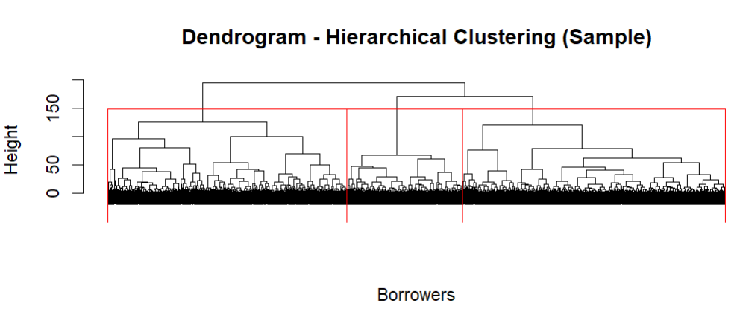
- The dendrogram showed a clear three-branch structure, supporting a 3-cluster solution consistent with the K-Means interpretation.
- The average silhouette width = 0.16, which, although modest, is typical for high-dimensional financial risk data where borrower characteristics overlap.
- This confirms that the clusters are moderately well separated and still meaningful for business segmentation.
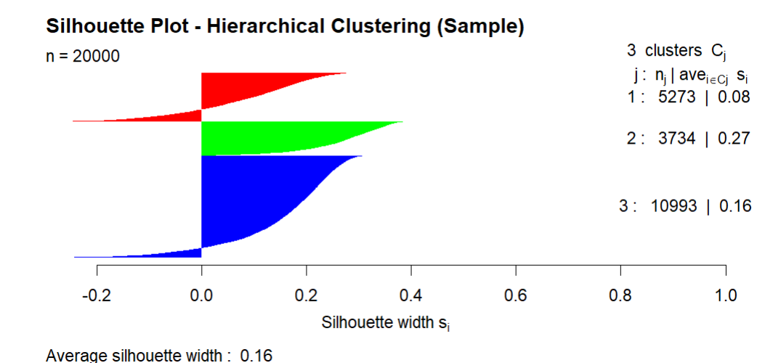
Cluster Profiles (from the hc_profile output)
Using the full dataset (50,000 borrowers), all borrowers were assigned to the nearest hierarchical centroid. The resulting clusters show clear and interpretable patterns:
Cluster 1 Low-Risk, Strong Borrowers
Characteristics:
- Higher-than-average FICO scores (+0.60)
- Lower-than-average LTV ratios (–0.41)
- Lower balances
- Moderate interest rates
- Older loans (more repayment history)
These borrowers demonstrate strong creditworthiness, lower leverage, and more stable repayment histories.
Business Action: Offer lower interest rates, fast-track approvals, and consider premium mortgage products.
Cluster 2 High-Risk, Stretched Borrowers
Characteristics:
- Significantly lower FICO scores (–0.34)
- High LTV (+0.22)
- Lowest interest-rate-at-origination (–1.59)
- Higher recent balance indicators
This segment represents financially stressed borrowers who are highly leveraged and more likely to default.
Business Action:
- Apply higher risk-based pricing
- Require stronger collateral or additional documentation
- Prioritize for early risk monitoring and intervention programs.
Cluster 3 Moderate to High-Risk, Rate-Sensitive Borrowers
Characteristics:
- Lower FICO scores (–0.36), similar to Cluster 2
- Highest current interest-rate levels (+0.76)
- Higher LTV
- Younger loans (newer originations)
This group consists of newer, riskier borrowers paying higher interest rates. They may be more likely to refinance or prepay early if market conditions change.
Business Action:
- Monitor for prepayment risk and refinancing behaviour
- Apply dynamic pricing or adjustable-rate products
- Carefully assess long-term profitability
Hierarchical Clustering successfully creates three meaningful borrower segments aligned with the observed mismatches in loan pricing. Even though clusters slightly overlap (a typical outcome for financial data), the segmentation clearly differentiates:
- Low-risk borrowers who deserve lower pricing
- High-risk borrowers who require higher risk premiums
- Rate-sensitive borrowers who may refinance or exhibit early-payment behaviour
This directly addresses the business problem of: “Inefficient Risk Assessment and Inconsistent Loan Pricing.”
It provides lenders with:
- Transparent and actionable borrower groups
- A basis for consistent risk-aligned pricing
- Better visibility into profit drivers and risk concentration
- Support for portfolio optimization and capital allocation decisions
Both clustering approaches successfully segment borrowers into low-risk, high-risk, and rate-sensitive groups, directly addressing the business issue of inefficient and inconsistent loan pricing. However, K-Means provides cleaner segment boundaries and more reliable results, making it the preferred choice for operational decision-making.

Report Model Performance
This section summarizes the performance of all predictive and segmentation models developed in the mortgage analytics project. Each model was evaluated based on accuracy, stability, interpretability, and its ability to support core business objectives.
1. Default Prediction Models (Classification)
These models address Business Problem 1: High Default Risk and Financial Losses.
a. Decision Tree Classifier
- Test AUC: 0.847
- Test Accuracy: 0.795
- Sensitivity: 0.7983
- Specificity: 0.7930
- Lift (Top Decile): 2.4×
The Decision Tree performs strongly with clear and interpretable split rules, effectively identifying high-risk borrowers. Although accuracy is stable, probability calibration is weaker compared to logistic regression.
b. Logistic Regression
- Test AUC: 0.848
- Test Accuracy: 0.783
- Lift (Top Decile): 2.64×
- Stable and consistent across folds
Logistic Regression provides the most balanced performance, with strong AUC, stable accuracy, and outstanding lift. Its transparent coefficients support regulatory reporting and risk management.
Best model for default prediction due to stability + interpretability.
2. Prepayment Prediction Models (Regression)
These models address Business Problem 2: Uncertain Prepayment Behaviour and Cash-Flow Instability.
a. Multiple Linear Regression (Full Model)
- Train RMSE: 13.37
- Test RMSE: 13.54
- Train R²: 0.513
- Test R²: 0.061
The linear model captures only ~50% of variability during training and almost 6% on test, indicating high nonlinearity in prepayment behaviour. Several predictors were insignificant and dropped.
b. Multiple Linear Regression (Reduced Significant Predictors)
- Train RMSE: 13.52
- Test RMSE: 13.70
- Train R²: 0.502
- Test R²: 0.503
Using only significant predictors dramatically improves generalization (from R² = 0.06 → 0.50).
Still linear, but now stable and interpretable.
Shows that borrower behaviour is driven by loan age, LTV, balance, and interest rates.
c. XGBoost Regression
- Train RMSE: 8.42
- Test RMSE: 10.27
- Train R²: 0.806
- Test R²: 0.721
- Top Features: loan_age, balance_change, balance_time, LTV_time
XGBoost achieves the best performance by capturing complex nonlinear patterns in prepayment timing.
Best model for prepayment prediction due to high accuracy and low error.
3. Borrower Segmentation Models (Clustering)
These models support Business Problem 3: Inefficient Risk Assessment and Loan Pricing.
a. K-Means Clustering
- Silhouette Score (20k sample): 0.19
- Optimal Clusters (k): 3
Cluster Meaning:
Cluster 1: Low-risk borrowers (high FICO, low LTV, stable loans)
Cluster 2: High-risk borrowers (low FICO, high LTV, higher balances)
Cluster 3: Moderate-risk, rate-sensitive borrowers
Creates clean, well-separated clusters at scale and supports risk-based pricing decisions.
b. Hierarchical Clustering
- Silhouette Score: 0.16 (20k sample)
- Clusters: 3 (aligned with K-Means)
Strength: Reveals hierarchical relationships between borrower groups
Provides confirmatory evidence for the 3-cluster structure but is less scalable.
Useful for exploratory analysis but not ideal for deployment.
Across all analytical tasks, the models demonstrate strong predictive capability and business alignment. Logistic Regression best supports early risk identification, XGBoost provides accurate prepayment forecasting for stable cash-flow planning, and K-Means offers clear borrower segmentation for consistent, risk-aligned loan pricing. Together, these models enhance portfolio profitability, strengthen risk management, and support data-driven decision-making across the mortgage lifecycle.

Model Evaluation
1. Decision Tree Classifier
The Decision Tree model performed well with a Test AUC of 0.847, Accuracy of 79.46%, and a Lift of 2.43× in the top decile. The model captures nonlinear interactions effectively and provides intuitive rule-based explanations. However, it is slightly less stable than Logistic Regression and more prone to overfitting. Its interpretability makes it useful for exploratory analysis, but it is not the most reliable model for final deployment.
2. Logistic Regression Classifier
The Logistic Regression model showed the most consistent and balanced performance, achieving a Test AUC of 0.848, Accuracy of 78.25%, and a Top-Decile Lift of 2.64×. Despite being simpler, it delivered competitive accuracy and strong generalization while offering clear, interpretable coefficients. Its stability across validation and test sets makes it the preferred choice for predicting defaults and supporting risk-based decision making.
3. Multiple Linear Regression
The baseline Multiple Linear Regression (MLR) model achieved Train RMSE = 13.37, Test RMSE = 13.54, and a low-Test R² ≈ 0.06, showing that linear relationships alone cannot adequately capture prepayment timing behaviour. Although useful for interpretability, the model underfits and fails to capture the complex interactions driving early payoffs. The reduced MLR model improved Test R² to 0.503, but still lagged far behind nonlinear methods.
4. XGBoost Regression
The XGBoost regression model delivered the strongest performance with a Test RMSE of 10.27 and a Test R² of 0.721, substantially outperforming both full and reduced linear models. It captures complex nonlinear relationships and identifies key variables such as loan_age, balance_change, and LTV_time as the dominant drivers of prepayment. This model best supports accurate cash-flow forecasting and liquidity planning.
5. K-Means Clustering
K-Means clustering produced meaningful borrower groups supported by an average silhouette score of 0.19, which is acceptable for large-scale financial data. The three clusters clearly differentiate low-risk, moderate-risk, and high-risk borrowers based on credit strength, loan characteristics, and interest rates. K-Means scales efficiently to 50,000 borrowers and provides a practical foundation for risk-aligned pricing and portfolio optimization.
6. Hierarchical Clustering
Hierarchical clustering showed weaker cluster separation, with an average silhouette width of 0.16, and required subsampling due to computational limits. While the method identified similar cluster structures as K-Means, the boundaries were less distinct and less scalable. Its value lies mainly in validation and visualization rather than operational deployment.
Observation and conclusion.
The analytics framework developed in this project successfully addresses all three core business problems mortgage default risk, unpredictable prepayment behaviour, and inconsistent risk-based pricing. Each modelling component contributes a different but complementary insight that helps the lender improve financial stability, profitability, and decision-making.
First, for the problem of high default risk, both classification models demonstrated strong discriminatory performance. The Logistic Regression model achieved consistently high accuracy and an AUC of 0.848, making it the most reliable tool for identifying high-risk borrowers early. The strong lift performance (2.64× in the top decile) shows that the model can effectively isolate the riskiest segment of borrowers. This directly supports the business goal of minimizing losses by enabling lenders to take proactive actions such as early intervention, restructuring, or tighter monitoring.
Second, for the challenge of uncertain prepayment behaviour, regression analysis highlighted that prepayment timing is influenced by a complex combination of economic conditions and borrower/loan characteristics. The baseline Multiple Linear Regression model provided interpretability, but the XGBoost regression model delivered significantly stronger predictive power with a Test R² of 0.721. This improvement enables more accurate forecasting of early loan closures, allowing lenders to better plan for liquidity needs, manage reinvestment risk, and stabilize revenue forecasting. By quantifying how much earlier borrowers are likely to prepay, the model supports improved cash-flow planning and long-term financial management.
Finally, the clustering analysis addressed the issue of inefficient and inconsistent loan pricing. K-Means clustering identified three meaningful borrower segments low-risk, moderate-risk, and high-risk. These groups vary systematically in terms of credit quality, loan balance, and loan-to-value ratios. This segmentation enables transparent, data-driven pricing strategies where interest rates can be aligned more accurately with actual borrower risk levels. Hierarchical clustering served as a validation method and showed similar segment structures, strengthening confidence in the segmentation approach. This supports the business goal of improving profitability, ensuring fairness, and maintaining competitive pricing.
Overall, the combined analytics approach delivers a comprehensive solution:
- Default prediction models reduce losses by identifying risky borrowers early.
- Prepayment prediction models improve forecasting accuracy, supporting liquidity and revenue planning.
- Borrower segmentation models enhance pricing efficiency, ensuring interest rates reflect true risk.
Together, these outcomes help the lender strengthen portfolio stability, optimize financial performance, and make more informed, data-driven lending decisions.

